|  |
| --- |
| HCL Technologies Ltd. |
| MOTECH Framework – Technical insight & Tamil language support on IVR |
|  |

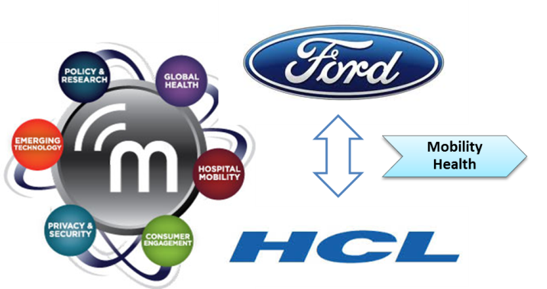

# Overview

1. MOTECH – Mobile Technology for Community Health
2. Open source platform for Mobility Health (mHealth) application
3. General features of MOTECH applications :
   1. Communicate information to patients by sending reminders, via **voice** or **SMS**
      * For appointments, lab visits, to take medicine.
      * To take medication
      * To take children for scheduled immunization services
   2. Collect data from patients or caregivers:
   3. Alert caregivers of the status of their patients
   4. Facilitate communication between patients, caregivers, and/or health administrators
4. Implementations
   1. Mobile Midwife & Nurses Application – Ghana
   2. TAMA – Urban India
   3. Ananya – Bihar, India
      * 1. MOBILE HANDSET APPLICATION FOR FRONT LINE HEALTH WORKERS (FLWS)
        2. IVR TRAINING TOOLS FOR FLWS
        3. KILKARI
   4. World Health Partners TB Case Management

# Architecture

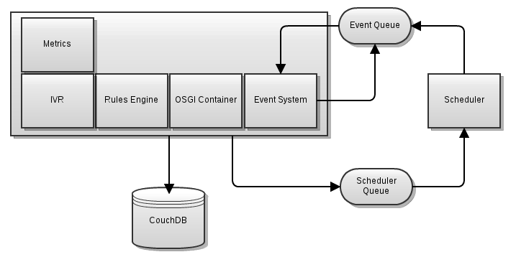

In a high level system architecture, MOTECH is logically divided into three tiers/layers :

* 1. Core layer
  2. Module layer
  3. Implementation layer

1. Core Layer

* Wraps several well-Known open source systems and exposes their features to the layers above it
* Wraps ActiveMQ and present an event interface to the module and implementation layers
* Provides an interface to the scheduler and access to CouchDB
* provides a module loading environment (OSGi- Open Service Gateway initiative)

1. Module Layer

* module layer is a collection of reusable components
* Modules interact with the core platform through its APIs
* Modules interact with other modules either through their service interfaces or by consuming their events
* Modules may also register servlet controllers which allow them to respond to HTTP requests.

1. Implementation Layer

* logical layer that contains implementation specific code

1. Stateless

* MOTECH is stateless – MOTECH server perform a single action per request and then return
* The module should never persist any state in memory and expect that state to be available to later requests

1. Events

* MOTECH engine provide an event system
* Any module can emit an event by calling the *eventRelay* and passing it a *MotechEvent* and a subject.
* To register for an event a module just needs to annotate a method with the list of event subjects or interest.

1. Scheduled Events & Timers

* MOTECH provides access to a flexible scheduling system
* Uses Quartz (open-source) application to schedule events

# Module List

Following are the modules available in the MOTECH suite:

1. [**Alerts**](http://www.motechproject.org/modules/alerts.html) :- Collects alerts for users in an inbox-like container
2. [**Appointments**](http://www.motechproject.org/modules/appointments.html) :- Provides appointment scheduling and reminding
3. [**CMS Lite**](http://www.motechproject.org/modules/cms-lite.html):- Provides basic content storage and retrieval
4. [**Decision Tree**](http://www.motechproject.org/modules/decision-tree.html) :- Provides APIs for constructing an IVR decision tree
5. [**IVR**](http://www.motechproject.org/modules/ivr.html):-Provides basic specification for integrating platform with an IVR service provider; Also, connects the platform IVR with an asterisk server using VoiceGlue VXML browser
6. [**IVR Kookoo**](http://www.motechproject.org/modules/ivr-kookoo.html):-Integrates the platform with [Kookoo's](http://www.kookoo.in/) hosted IVR
7. [**IVR Voxeo**](http://www.motechproject.org/modules/ivr-voxeo.html):-Integrates the platform with [Voxeo's](http://www.voxeo.com/) hosted IVR
8. [**Message** Campaign](http://www.motechproject.org/modules/message-campaign.html):-Enrolls users in message campaigns with flexible content scheduling rules
9. [**Mobile forms**](http://www.motechproject.org/modules/mobile-forms.html):-Supports configurable forms and data collection though mobile devices.
10. [**MRS (Medical Record System)**](http://www.motechproject.org/modules/mrs.html):-Provides basic specification for integrating platform with a medical record system
11. [**OpenMRS**](http://www.motechproject.org/modules/openmrs.html):-Integrates platform with OpenMRS system
12. [**Outbox**](http://www.motechproject.org/modules/outbox.html):-A voicemail like messaging system for end users
13. [**Pill Reminder**](http://www.motechproject.org/modules/pill-reminder.html):-A flexible reminder system focused on medication
14. [**Schedule Tracking**](http://www.motechproject.org/modules/schedule-tracking.html):-Enrolls users for alerts based on complex scheduling rules
15. [**SMS**](http://www.motechproject.org/modules/sms.html):-Provides basic specification for integrating platform with an SMS provider to send/receive SMS messages
16. [**SMS HTTP**](http://www.motechproject.org/modules/sms-http.html):-Allows platform to integrate with an HTTP-based SMS gateway to send SMS messages
17. [**SMS SMPP**](http://www.motechproject.org/modules/sms-smpp.html):-Allows platform to integrate with an SMPP-based SMS gateway to send/receive SMS messages

# Features

1. Demand Generation

* via IVR
* via SMS
* Scheduled messages to patients
* Scheduled messages to patients based on their medical record
* Appointment Reminders to patients

1. Registration

* via IVR
* via simple mobile form
* via CommCare
* via Web UI

1. Front Line Health Workers

* IVR messages
* SMS messages
* CommCare handset application
* mForms on handset
* Web-based UI
* Job Aids
* Medical protocols presented on mobile devices
* Defaulter alerts
* Nurses have patient lists and patient data on their handset
* Patient data synchronized between multiple FLWs' handsets
* Ability to search for patient data from handset
* Training
* Supervision & workforce management

1. Supply Chain Logistics

* Reporting stockouts
* Notification of new supply shipment
* Inventory management
* Adherence Monitoring
* Pill reminders & Adherence monitoring
* Basic Referrals
* Robust Referrals

1. Integration

* OpenMRS: Integration via OpenMRS omod
* OpenMRS: Integration via OpenMRS atom feed
* OpenMRS: Bi-directional integration between MOTECH and OpenMRS
* DHIS2
* External ID systems
* MCTS
* ReMeDi

1. Hosting

* Self-hosted
* Hosted in the cloud

# Installation & Dependent Software

Following are software requirements in Linux platform

1. OS required – **Ubuntu lucid** in 64-bit machine
2. Dependent Systems/Platform
   1. [Tomcat7](http://tomcat.apache.org/download-70.cgi)
   2. [ActiveMQ](http://activemq.apache.org/activemq-551-release.html)
   3. [CouchDB](http://couchdb.apache.org/downloads.html)
   4. [MySQL](http://dev.mysql.com/downloads/mysql/5.5.html)
   5. Quatrz
3. Dependent software
   1. Java7
   2. Git
   3. Maven 3
   4. Curl

# References

**For software installation, follow the URLs:**

1. <http://www.motechproject.org/devdocs/installation.html>
2. <http://motechsuite.org/index.php/installing-motech>

**For running MOTECH, refer below URL:**

<http://motechsuite.org/index.php/installing-motech>

* <http://www.motechsuite.org/>
* <http://www.motechproject.org/>
* <https://code.google.com/p/motech/>

# Queries

1. Is it possible to configure MOTECH Suite in windows platform? If yes, what are the dependencies and external packages required?
2. Which IVR is used in MOTECH and is it open source?